Used Car Price Prediction and Market Insights

Project Overview
This project aims to predict the resale price of used cars based on key attributes such as car age, kilometers driven, fuel type, transmission, seller type, and ownership history.
The objective is to demonstrate data analytics and machine learning capabilities that provide actionable insights to car dealers, buyers, and resale platforms.
Dataset Details
Source: CarDekho Dataset (Kaggle) : https://www.kaggle.com/datasets/nehalbirla/vehicle-dataset-from-cardekho?resource=download
- Records: 4,340 rows → cleaned to 3,577 after duplicate removal
- Features:
  - year → converted to car_age
  - km_driven, fuel, seller_type, transmission, owner, selling_price

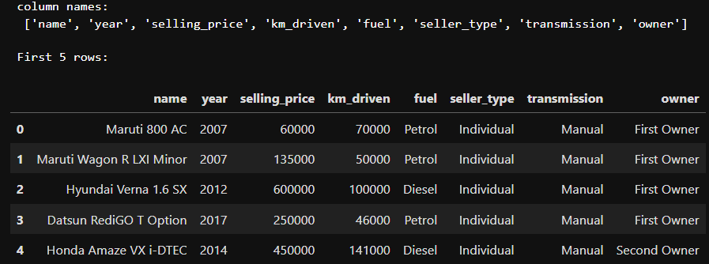
Figure 1:“first 5 rows” DataFrame preview.

Data Preprocessing
Steps performed:
- Removed 763 duplicate rows
- Handled inconsistent column names (e.g., renamed “ year ” → “year”)
- Created new feature → car_age = 2020 - year
- Dropped irrelevant columns like car name

Figure 2:Dataset shape after cleaning
Exploratory Data Analysis (EDA)
EDA was conducted to understand price behavior across factors:
4.1 Distribution Insights
- Selling Price: Highly right-skewed — most cars under ₹10L.
- Car Age: Majority between 3–10 years.
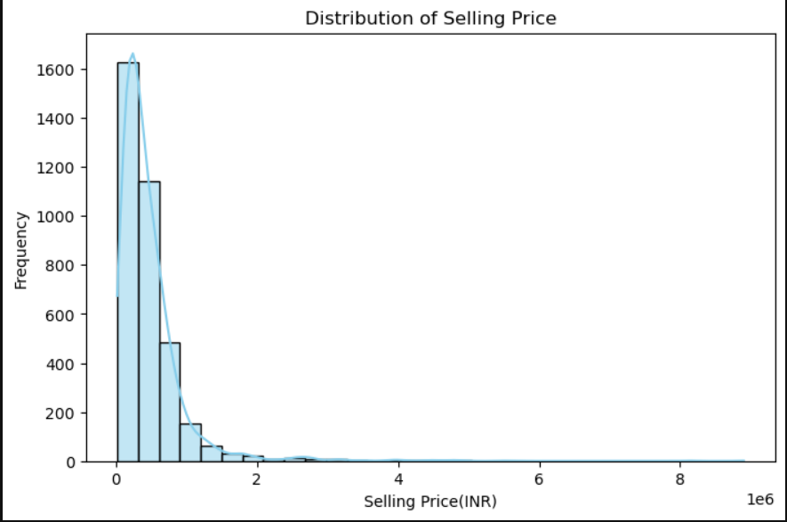

Figure 3:Distribution of Selling Price
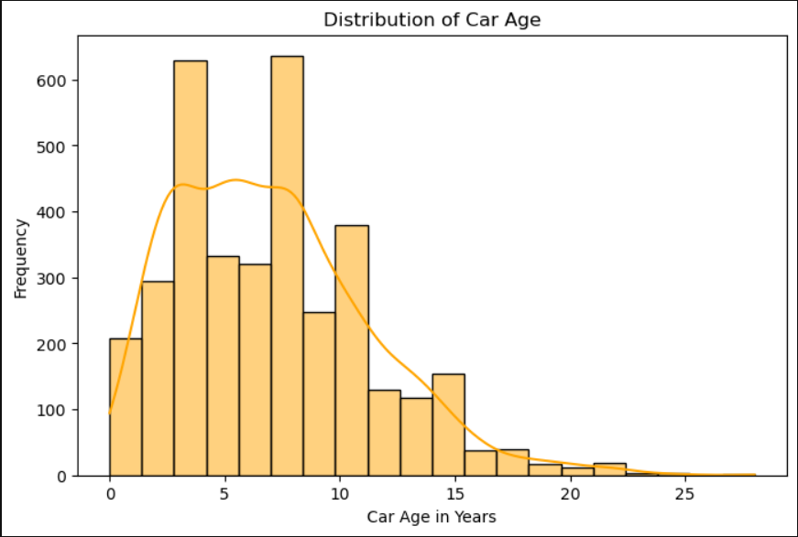
Figure 4:Distribution of car age

4.2 Correlation Insights
- Car Age (-0.42) and km_driven (-0.19) negatively correlated with price.
- Older, higher-mileage cars → lower resale value.
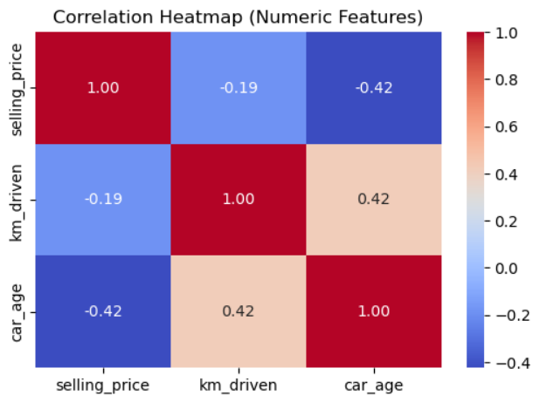
Figure 5:Correlation Heatmap (numeric features)

4.3 Categorical Feature Insights
- Automatic cars have higher resale prices.
- Diesel and Petrol cars dominate higher resale bands.
- Dealer listings show slightly higher prices than individuals.
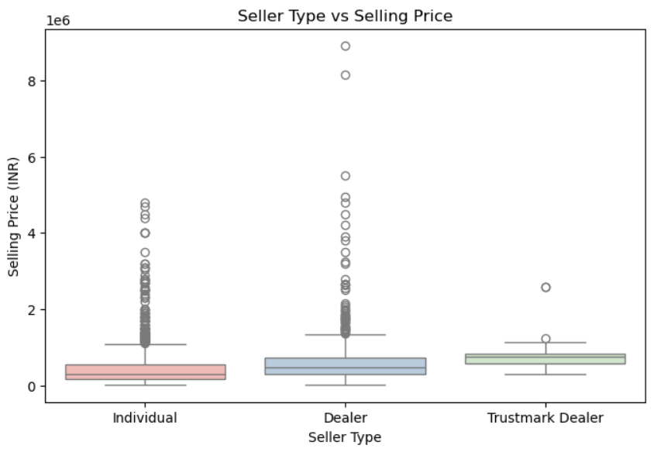
Figure 6:Fuel Type vs Selling Price

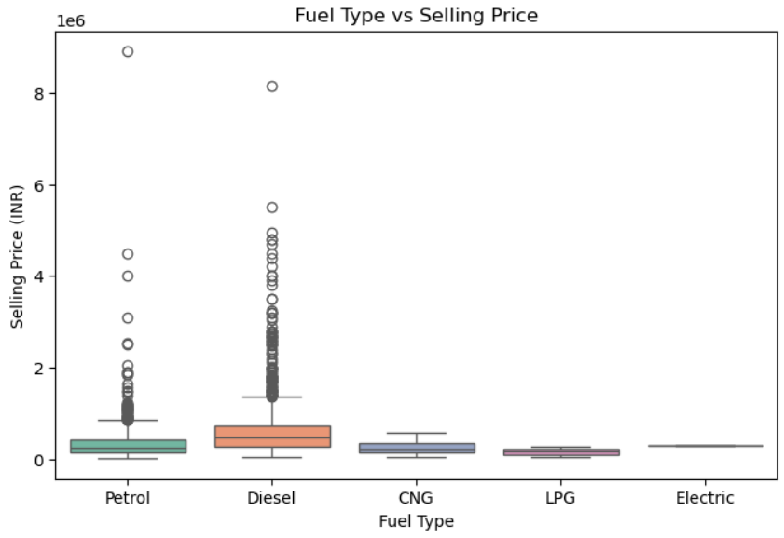
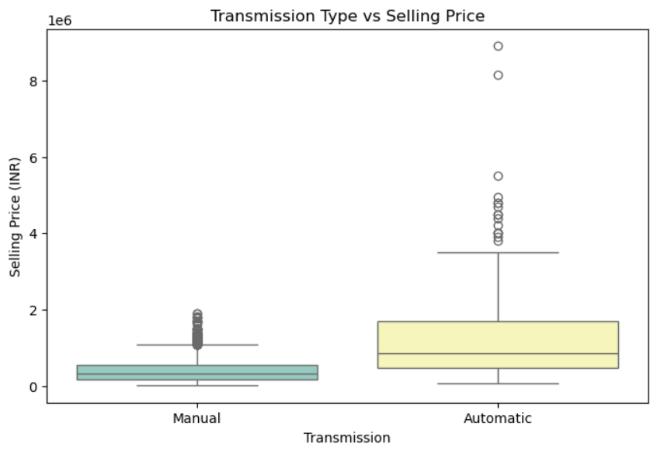
Figure 7:Fuel Type vs Selling Price
Figure 8:Transmission vs Selling Price

Model Development
Two regression models were trained:
- Linear Regression
- Random Forest Regressor (final model)

Random Forest gave better performance.
Metric | Linear Regression | Random Forest
R² | 0.32 | 0.45
MAE | 2.21L | 1.94L
RMSE | 4.9L | 4.2L

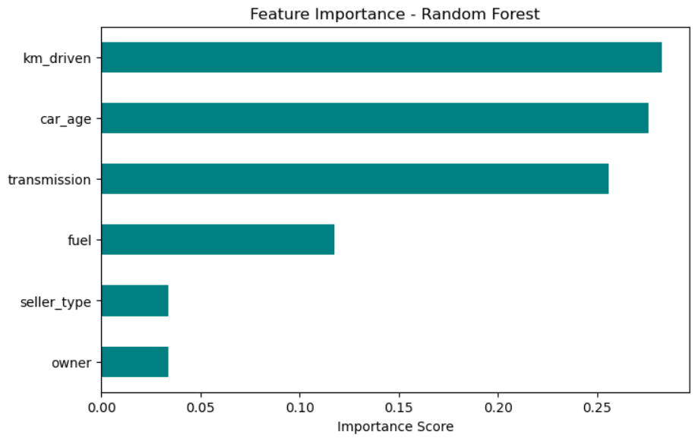

Figure 9: Feature Importance - Random Forest

Model Evaluation
R² = 0.45 → Model explains 45% of price variation
Residuals centered near zero → errors are mostly unbiased
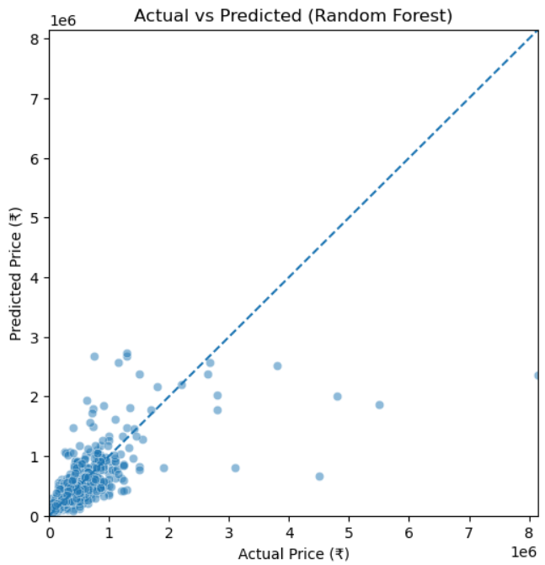
Figure 10:Actaul vs Predicted

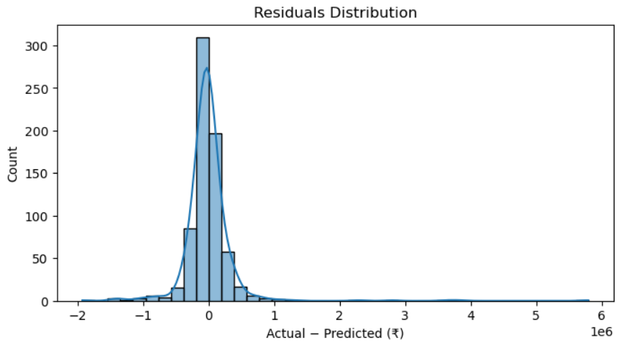
Figure 11:Residuals Distribution

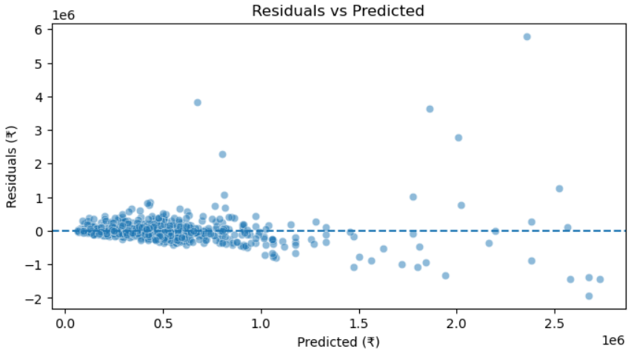
Figure 12:Residuals vs Predicted
Key Insights
- Top price drivers:
  - km_driven, car_age, and transmission type.
- Automatic cars, low mileage, and newer models tend to fetch premium resale prices.
- The dataset shows a heavy dominance of Petrol and Diesel vehicles — newer Electric cars appear underrepresented (limited market adoption).
These insights can be integrated into Power BI dashboards for prescriptive analytics.
Business Value
- For Buyers: Understand depreciation to negotiate better deals.
- For Dealers: Predict fair pricing and identify undervalued listings.
- For Platforms (like OLX, Cars24): Build AI-driven price recommendation systems.
This predictive-prescriptive workflow can be reused for other pricing or valuation scenarios (real estate, electronics, etc.).

Conclusion
This project demonstrates the ability to apply data cleaning, exploratory analysis, feature engineering, and predictive modeling to solve real-world business problems in the used car market.
By leveraging machine learning, the model provides price transparency for buyers and supports dealers in making data-driven pricing decisions.
The workflow also showcases an end-to-end analytics pipeline, from raw data to actionable insights, reflecting strong alignment with the responsibilities of Data Analyst, Business Analyst, or BI Consultant roles.

